

Data Base System

Course Work Report

Parts A and B

Name: R.M.S.J. Bandara

UOW Number: w1866979

IIT Number: 20200649

Group B

Table of Contents

Entity Relationship Diagram 2

Data Dictionaries 3

2.1 Entities 3

2.2 General Entity 4

2.3 Relationships & Multiplicities 5

2.4 Attributes & Primary Keys 6

3. BoilHeater Database part B 8

3.1 Logical Entity Relationship Diagram 8

3.2 MySQL Screenshots 9

3.2.1 Create Database 9

3.2.2 Create customer Table 10

3.2.3 Create oneoff_payment Table 11

3.2.4 Populating customer Table 12

3.2.5 Populating oneoff_Payment Table 14

3.2.6 Query 16

4 MySQL and MongoDB 17

# Entity Relationship Diagram

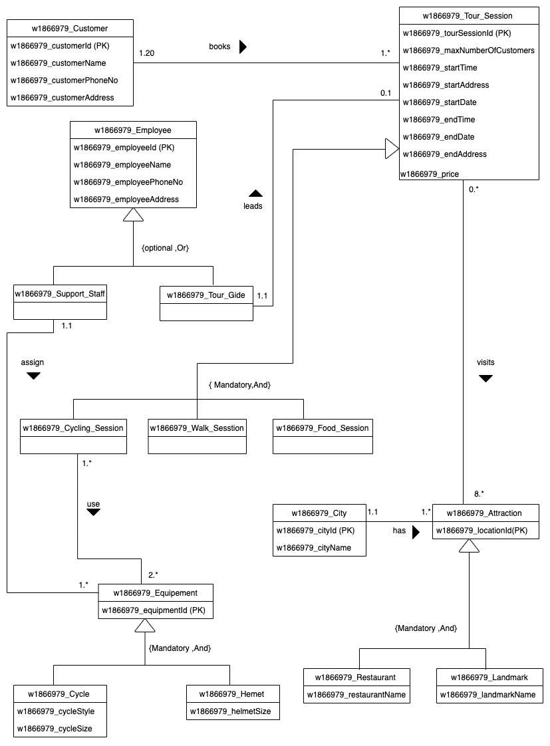

# Data Dictionaries

## 2.1 Entities

|  |  |
| --- | --- |
| Entity Name | Brief Description |
| w1866979_Customer | Describing customers of tourmato |
| w1866979_City | Describing cities provide in tourmato service |
| w1866979_Attraction | Describing places in tour session |
| w1866979_Tour_Session | Describing Tour session information |
| w1866979_Employee | Describing employees in tourmato |
| w1866979_Support_Staff | Describing employees to maintain the equipment |
| w1866979_Tour_Guide | Describing tour guide tour session to attraction in tourmato |
| w1866979_Cycling_Session | Describing tour session by cycling to attraction places |
| w1866979_Walk_Sesstion | Describing tour session by walking to attraction places |
| w1866979_Food_Session | Describe the tour session visiting different restaurants |
| w1866979_Restaurant | Describing restaurants in tour session |
| w1866979_Landmark | Describing the land marks in the city |
| w1866979_Equipement | Describing equipment in the tour session |
| w1866979_Cycle | Describing transport equipment in tour session |
| w1866979_Hemet | Describing the equipment while using the cycle |

## 2.2 General Entity

|  |  |  |
| --- | --- | --- |
| General Entity | Specialised Entity | Brief Explanation |
| w1866979_Tour_Session | w1866979_Cycling_Session | Cycle used move to attractions in the tour section |
| w1866979_Walk_Sesstion | Walking to attraction places in the tour session |
| w1866979_Food_Session | Visit a different restaurant and taste different foods in the tour session |
| w1866979_Employee | w1866979_Support_Staff | Crew members maintain equipment |
| w1866979_Tour_Gide | Crew members guide the customers in tour session |
| w1866979_Attraction | w1866979_Restaurant | Restaurants in tour session |
| w1866979_Landmark | Landmarks in tour session |
| w1866979_Equipement | w1866979_Cycle | Cycle use to cycle session |
| w1866979_Hemet | Equipment use for protection while riding cycle |

## 2.3 Relationships & Multiplicities

|  |  |  |  |  |  |
| --- | --- | --- | --- | --- | --- |
| Entity Name | Multiplicity | Relationship | multiplicity | Entity name | Brief Justifications for the Multiplicity |
| w1866979_Customer | 1.* | books | 1.* | w1866979_ Tour Session | One Customer need to book at least one tour session |
| One Customer can book many tour Sessions |
| A Tour session has at least one customer |
| A Tour session may have 20 maximum customers |
| w1866979_Tour Session | 0.* | visits | 8.* | w1866979_ Attraction | A Tour session visits a minimum of 8 attraction |
| A Tour session can visit many attraction |
| One attraction may not visit tour session |
| One attraction has many tour session |
| w1866979_Tour  Guide | 1.1 | leads | 0.1 | w1866979_ Tour  Session | A Tour guide may not leads a tour session |
| A Tour guide may lead a one tour session |
| One Tour session must lead one tour Guide |
| One Tour session can lead by only one tour guide |
| w1866979_Support Staff | 1.1 | assign | 1.* | w1866979_ Equipment | One Support staff may not be assign equipment |
| One Support staff can be assigned to many equipment |
| One Equipment must be assigned to one person |
| One Equipment assign to at least one person |
| w1866979_Cycling Session | 1.* | use | 2.* | w1866979_ Equipment | One Cycle session must use at least two equipment |
| One Cycle session can use many equipment |
| One Equipment may use to one cycle session |
| One Equipment can be use many cycling session |
| w1866979_City | 1.1 | has | 1.* | w1866979_ Attraction | One City has at least one attraction |
| One City has many attractions |
| One Attraction must have located one city |
| One Attraction may have one city |

## 2.4 Attributes & Primary Keys

|  |  |  |
| --- | --- | --- |
| Entity Name | Attribute of this entity | Brief explanation |
| w1866979_Customer | w1866979_customerId (PK) | Uniquely identify customer |
| w1866979_customerName | Customers full name |
| w1866979_customerPhoneNo | Customer phone number |
| w1866979_customerAddress | Customer address |
| w1866979_Employee | w1866979_employeeId (PK) | Uniquely identify employee |
| w1866979_employeeName | Employee name |
| w1866979_employeePhoneNo | Employee phone number |
| w1866979_employeeAddress | Employee address |
| w1866979_Tour_Session | w1866979_tourSessionId (PK) | Uniquely identify tour session id |
| w1866979_maxNumberOfCustomers | Maximum number of customers for tour session |
| w1866979_startTime | Tour session start time |
| w1866979_startAddress | Tour session start address |
| w1866979_startDate | Tour session start date |
| w1866979_endTime | Tour session end time |
| w1866979_endDate | Tour session end date |
| w1866979_endAddress | Tour session end Address |
| w1866979_price | Tour session price |
| w1866979_City | w1866979_cityId (PK) | Uniquely identify city |
| w1866979_cityName | City name |
| w1866979_Attraction | w1866979_locationId (PK) | Uniquely identify attraction |
| w1866979_Restaurant | w1866979_restaurantName | Name of the restaurant |
| w1866979_Landmark | w1866979_landmarkName | Name of the landmark |
| w1866979_Equipement | w1866979_equipmentId (PK) | Uniquely identify equipment |
| w1866979_Cycle | w1866979_cycleStyle | Cycle style |
| w1866979_cycleSize | Cycle size |
| w1866979_Hemet | w1866979_helmetSize | Helmet size |
| w1866979_Cycling_Session |  |  |
| w1866979_Walk_Sesstion |  |  |
| w1866979_Food_Session |  |  |
| w1866979_Support_Staff |  |  |
| w1866979_Tour_Gide |  |  |

# 3. BoilHeater Database part B

## 3.1 Logical Entity Relationship Diagram

## 3.2 MySQL Screenshots

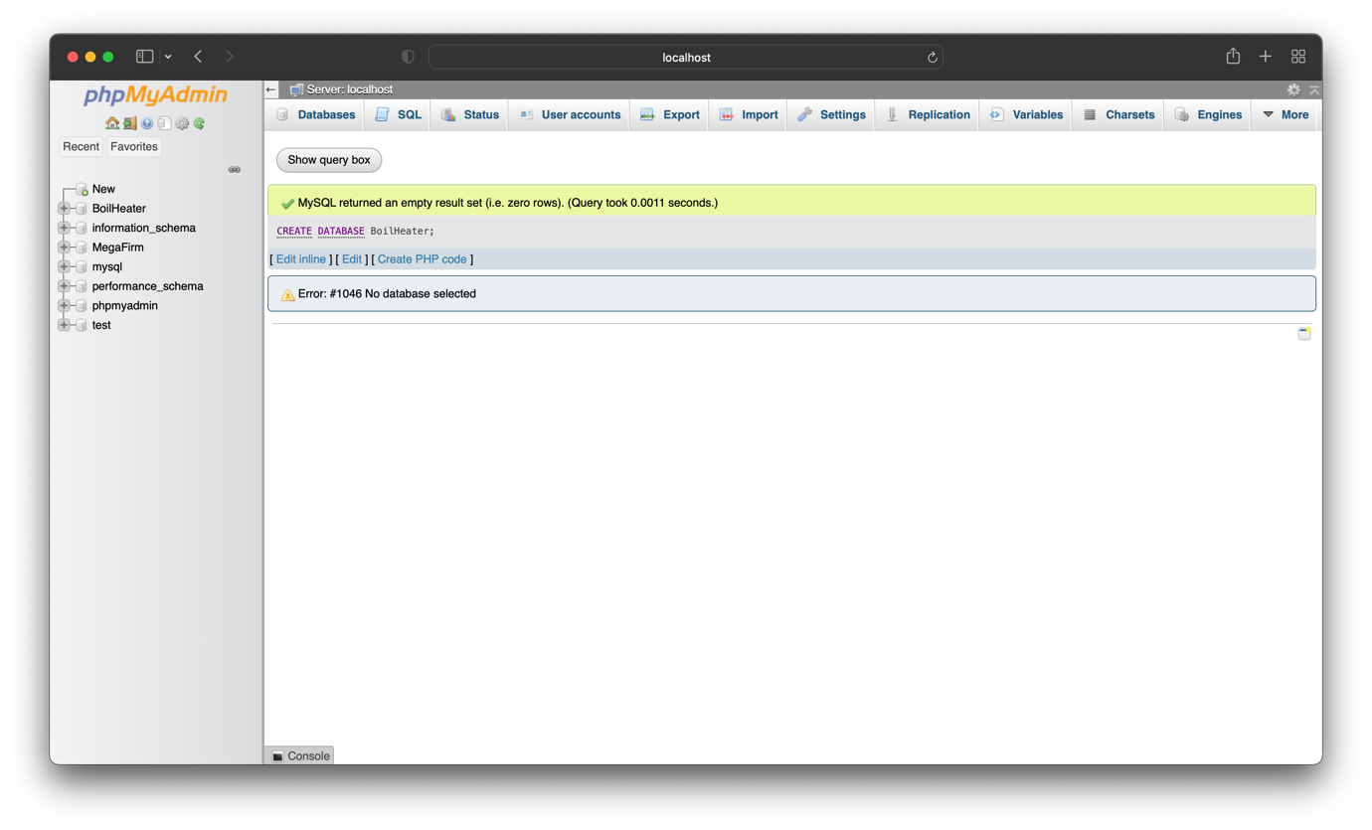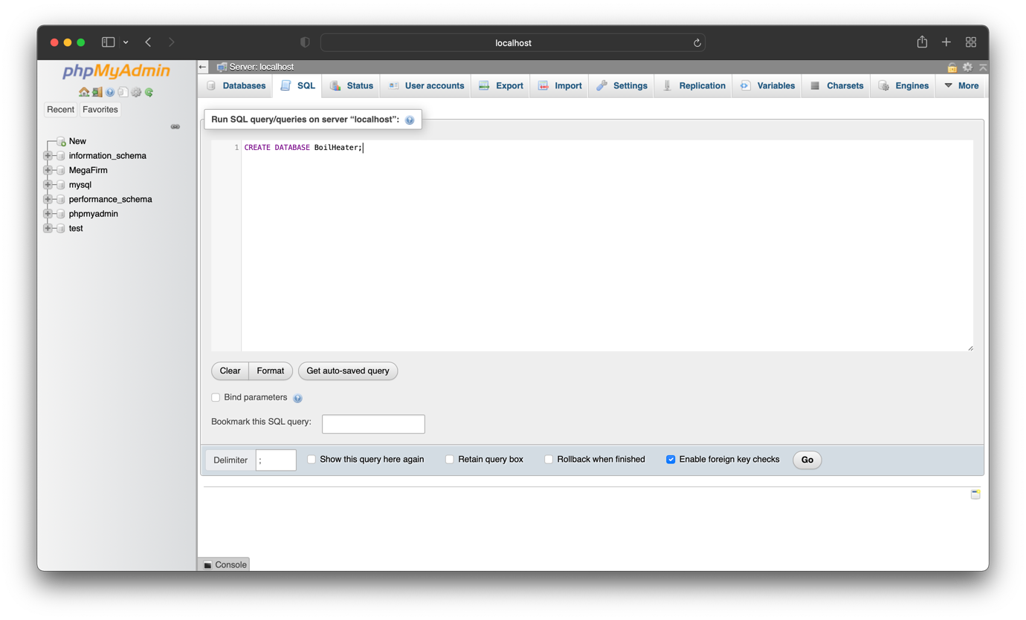3.2.1 Create Database

### 3.2.2 Create customer Table

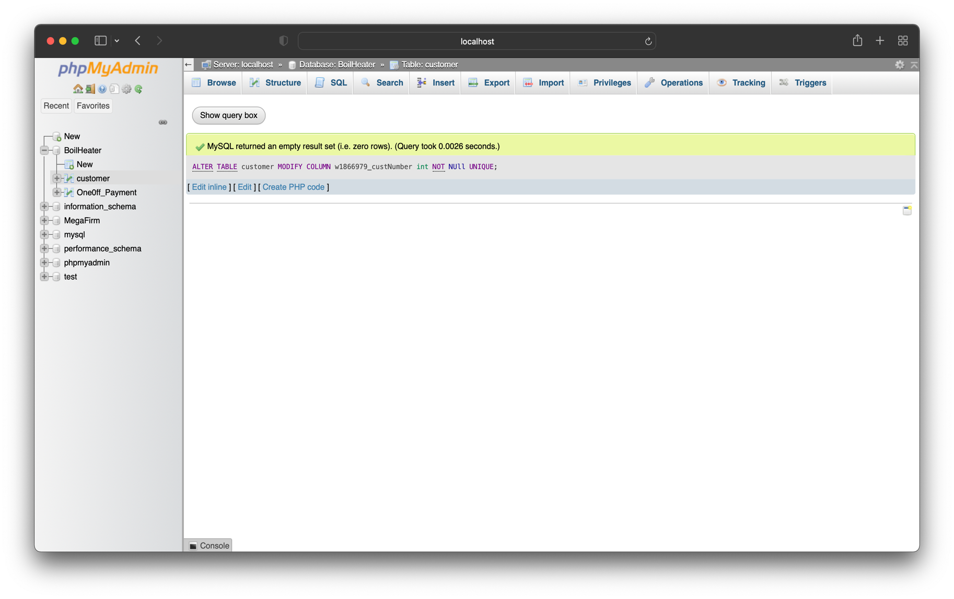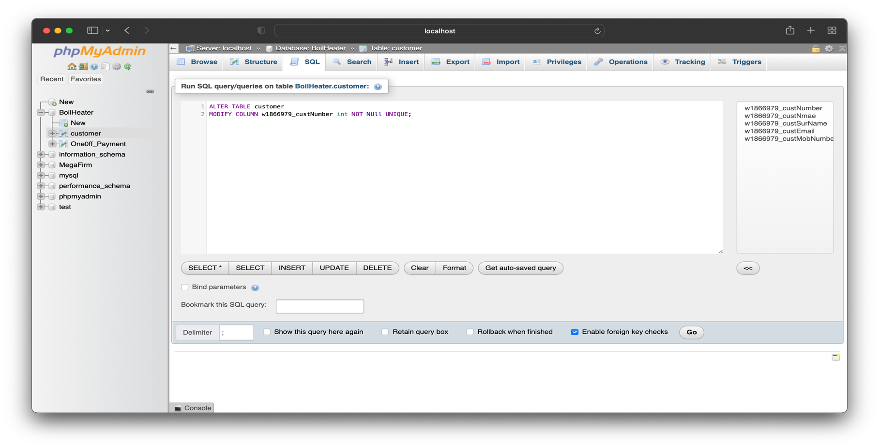3.2.3 Update primary key

### 3.2.4 Create oneoff_payment Table

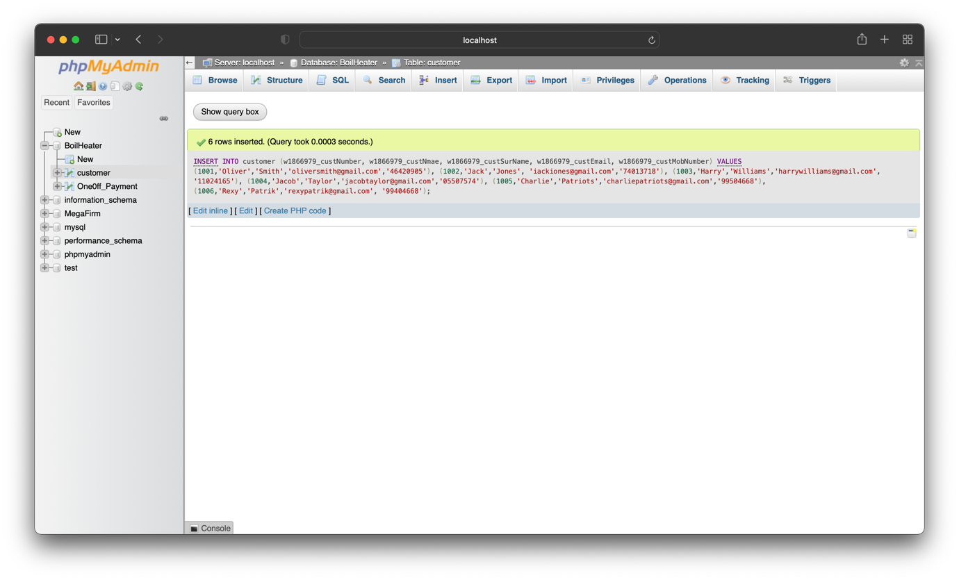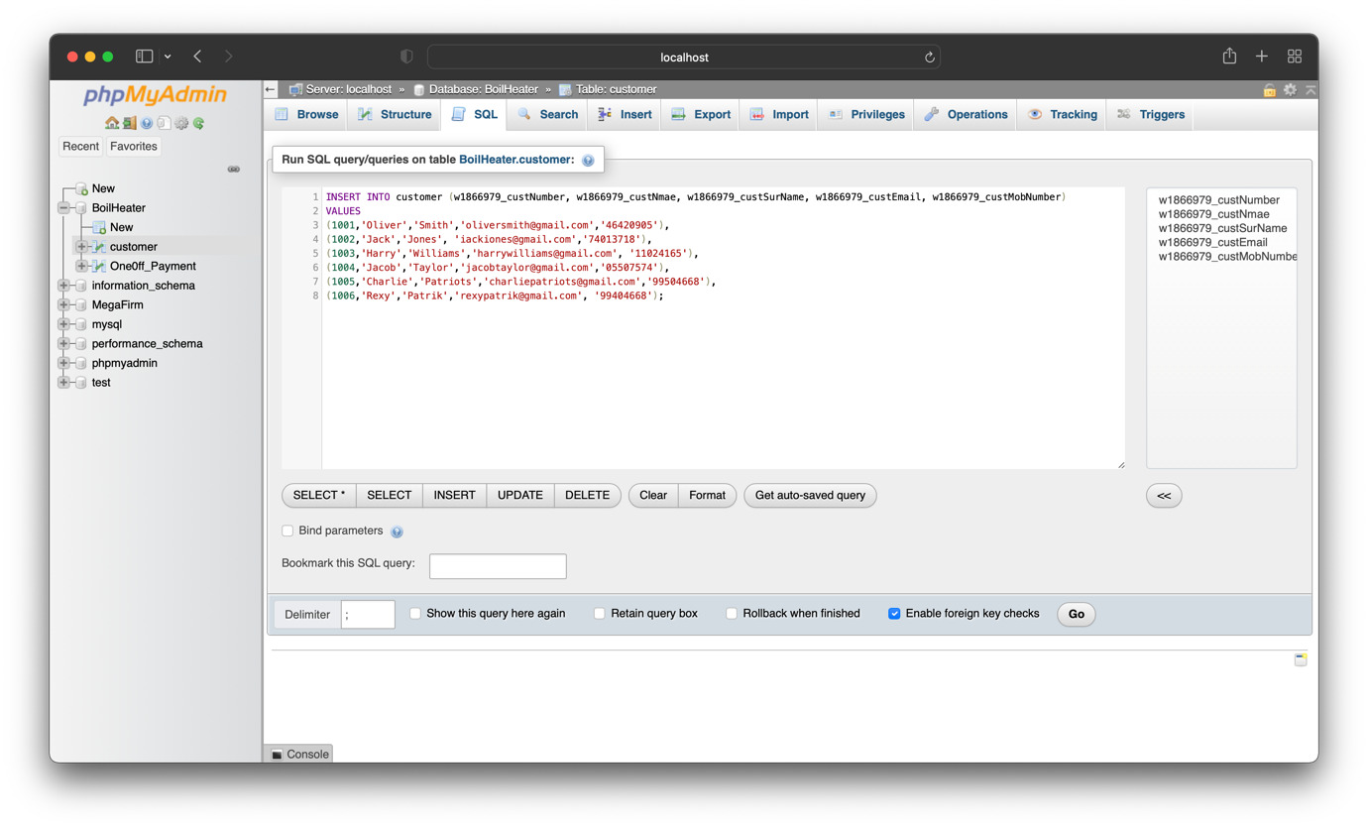3.2.5 Populating customer Table

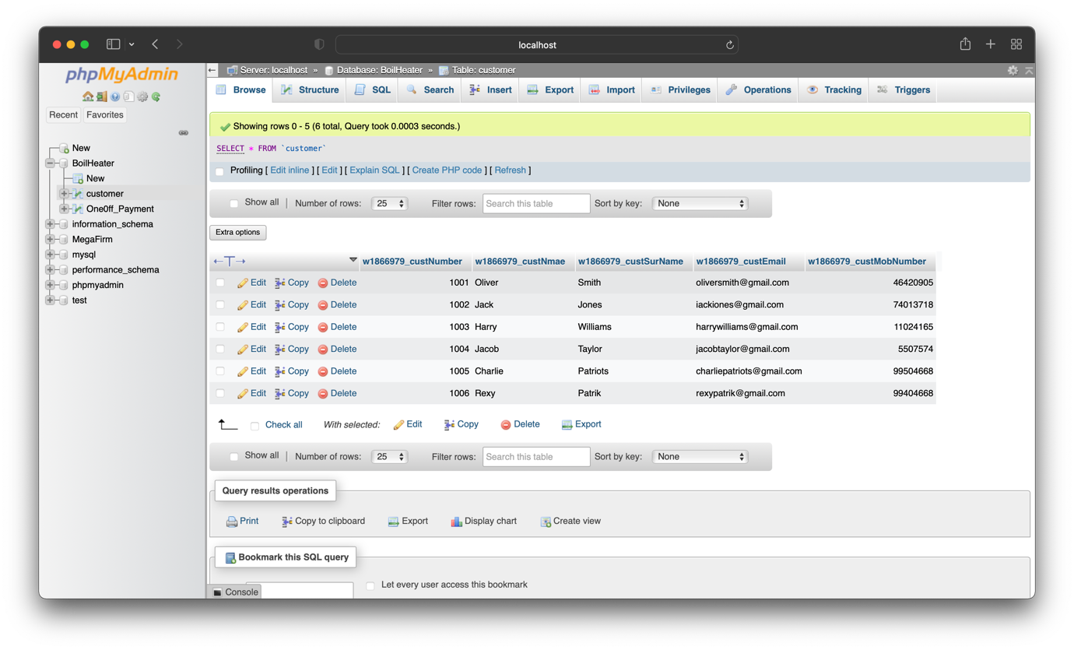

### 3.2.6 Populating oneoff_Payment Table

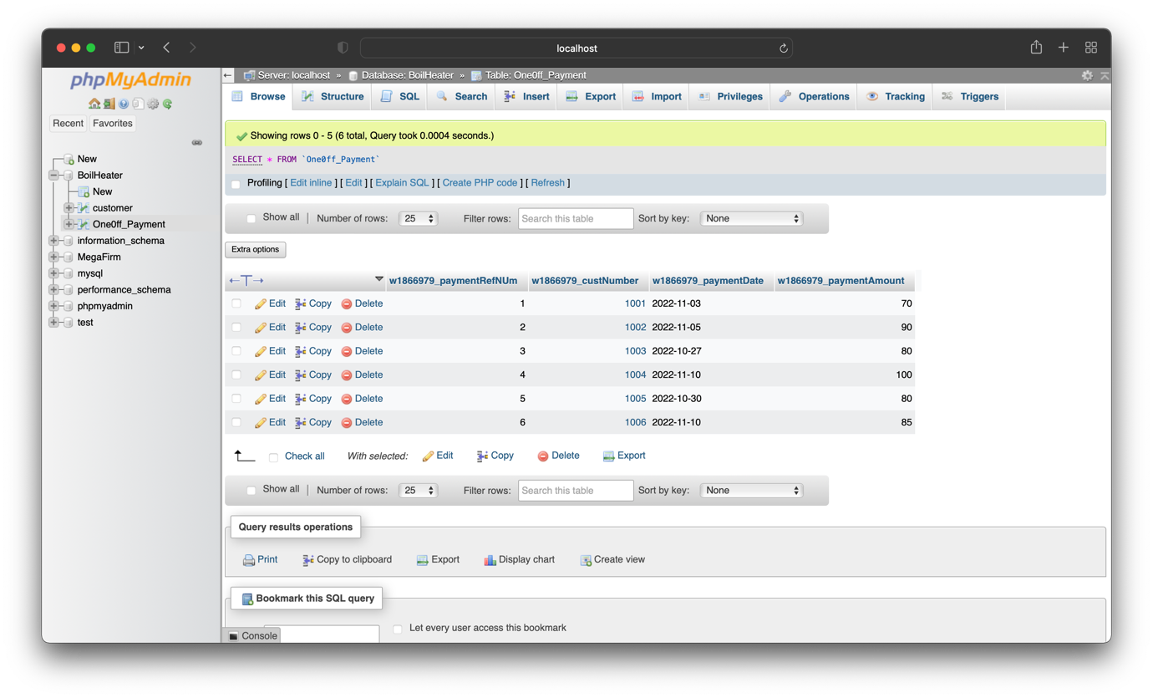

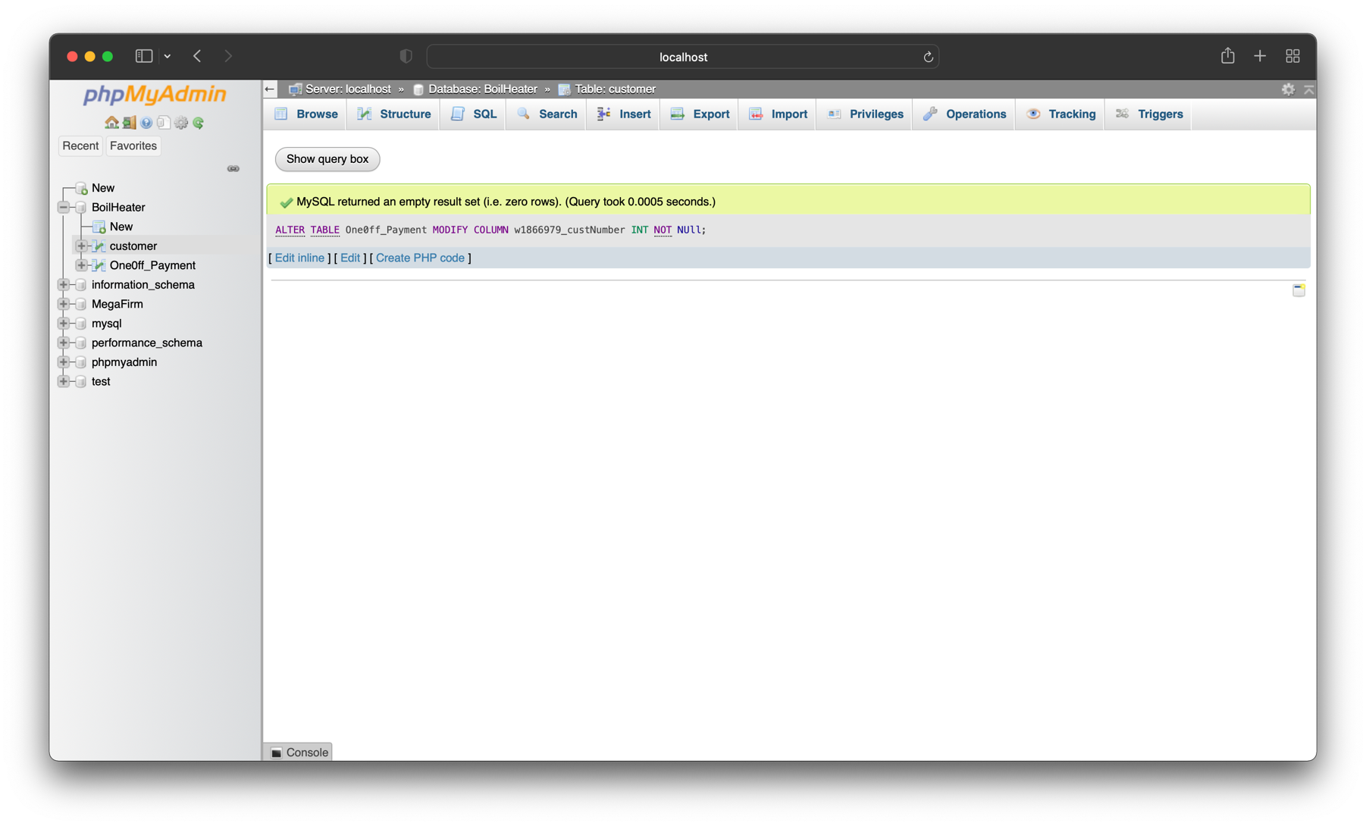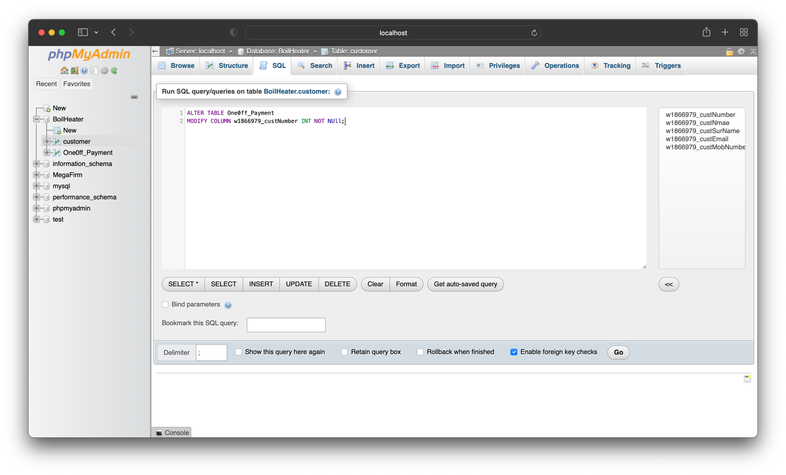3.2.7 Update foreign key

### 3.2.8 Query

# 4 MySQL and MongoDB

|  |  |
| --- | --- |
| MySQL | MongoDB |
| open-source relational database management system (RDBMS) | open-source non-relational database management system (NoSQL) |
| MySQL is quite slow in comparison to MongoDB while dealing with large databases. | It has the ability to handle large unstructured data |
| Constant development is done by the Oracle Corporation. | Ongoing development is done by MongoDB, Inc. |
| options for scalability are much more limited. | the database is extremely easy to scale |
| MySQL supports JOIN operations. | MongoDB doesn’t support JOIN. |
| Supported languages are C++, C and JavaScript | Supported languages are C++, C |
| In MySQL, each individual records are stored as ‘rows’ in a table | In MongoDB, each individual records are stored as ‘documents’. |
| A ‘table’ is used to store rows (records) of similar type. | Documents belonging to a particular class or group as stored in a ‘collection’. |
| MySQL concept does not allow efficient replication and sharding but in MySQL, one can access associated data using joins which minimizes duplication. | MongoDB was designed with high availability and scalability in mind, and includes out-of-the-box replication and sharding. |
| Risk of SQL injection attacks | No schema definition required so lesser risk of attack due to design |

# Reference

* Comparing The Differences - MongoDB Vs MySQL. (no date). *MongoDB*. Available from https://www.mongodb.com/compare/mongodb-mysql [Accessed 7 December 2022].
* MongoDB vs MySQL. (2018). *GeeksforGeeks*. Available from https://www.geeksforgeeks.org/mongodb-vs-mysql/ [Accessed 7 December 2022].
* Taylor, D. (2020). MongoDB vs MySQL – Difference Between Them. Available from https://www.guru99.com/mongodb-vs-mysql.html [Accessed 7 December 2022].